**DUAL BOOTIN EXERCISE**

**Create a document with screenshots to explain the answer for each exercise**

1. Create a virtual machine with two operating systems, Windows 7 and Windows 10 (in this order). Choose Windows 7 as the default operating system, which will boot after 5 seconds unless Windows 10 is manually selected.

We are going to start creating a new virtual machine for Windows 7 with 4GB of RAM and 70GM of memory.

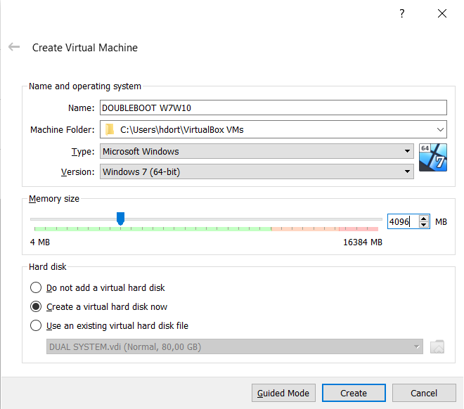

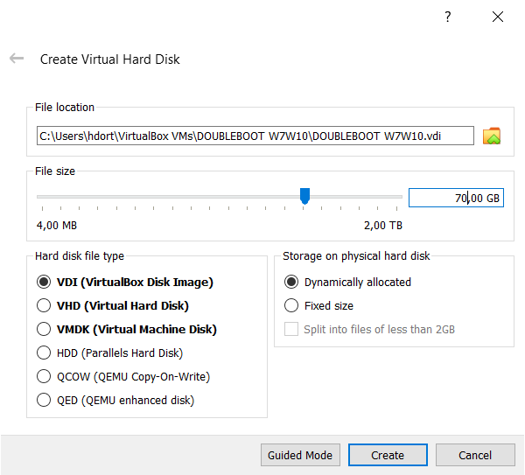

* Select Windows 7 (64bits), in order to installed.

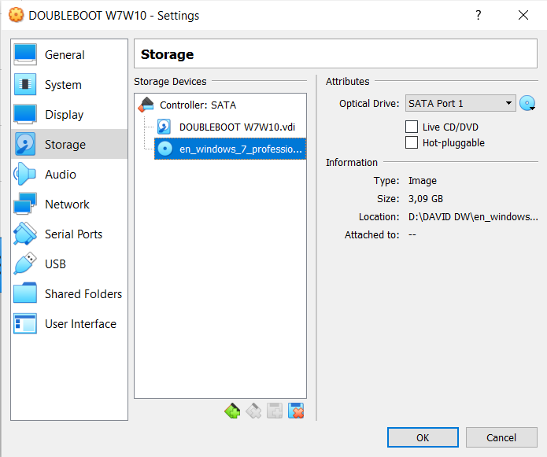

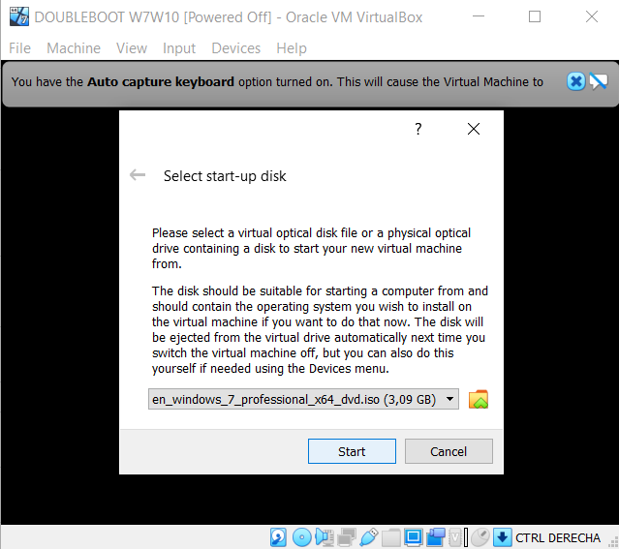

* As usually we have to configurate the operating system, we selected the laguage an the right keyboard, in our case a spanish one.

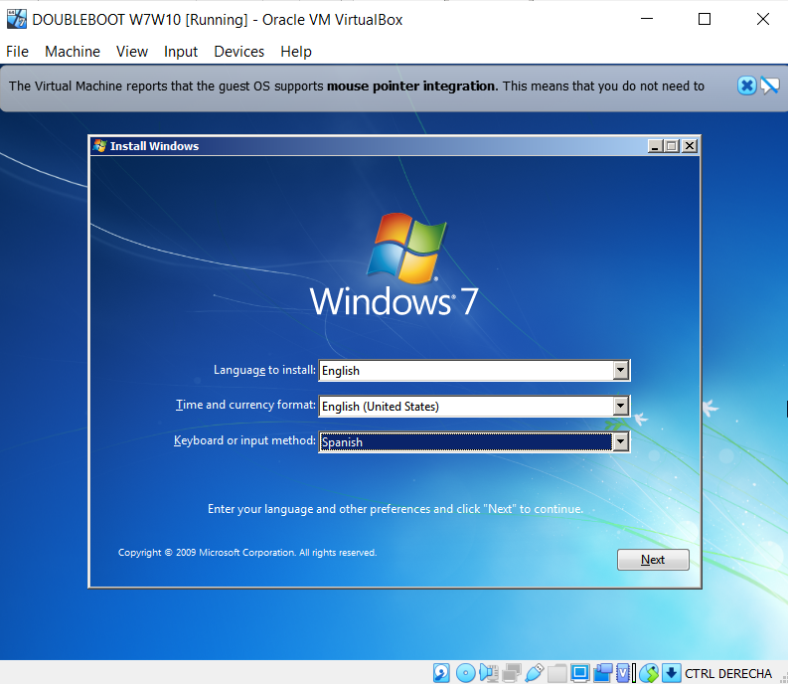

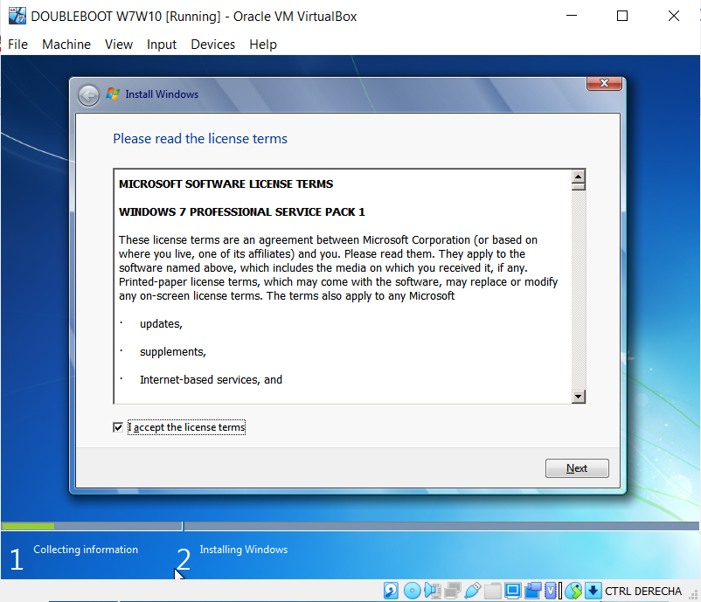

* In the next screen we have to create two partitions in order to have one partition for each OS.

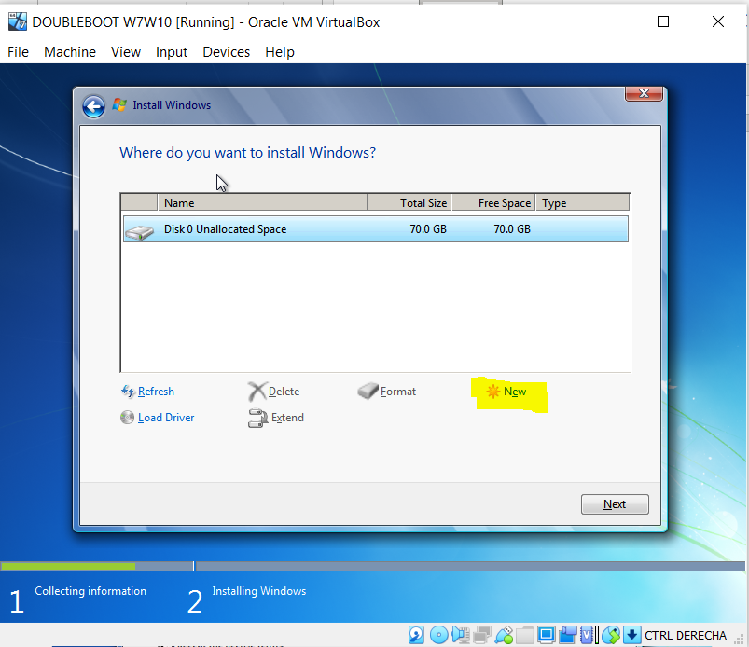

* 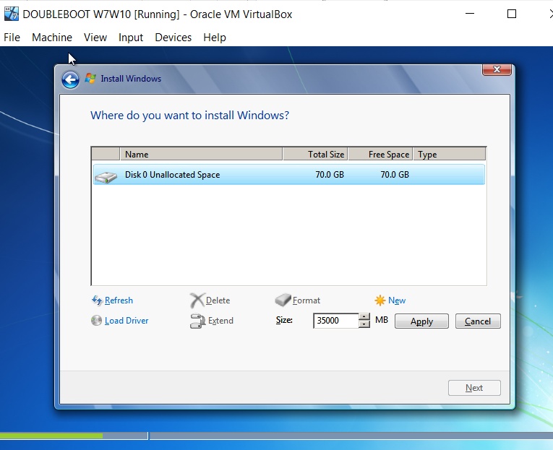Here we must to choose the size for each partition.

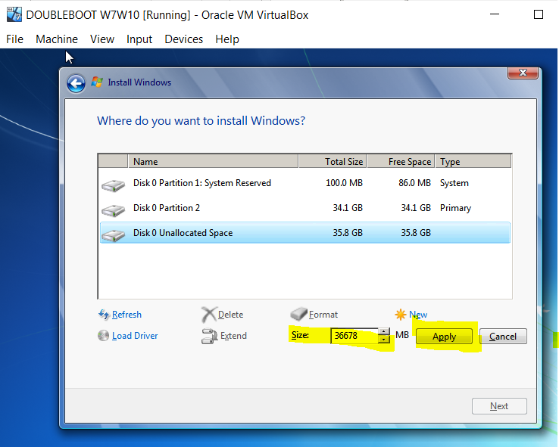

* Then we have our patitions:

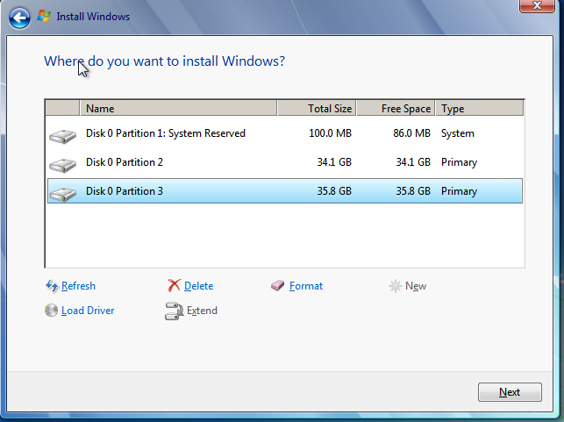

-In this point we have to continue with the installation as normaly do. And we finally have our Windows 7 installed.

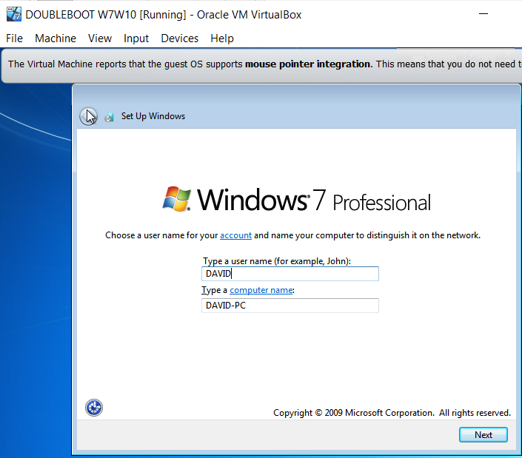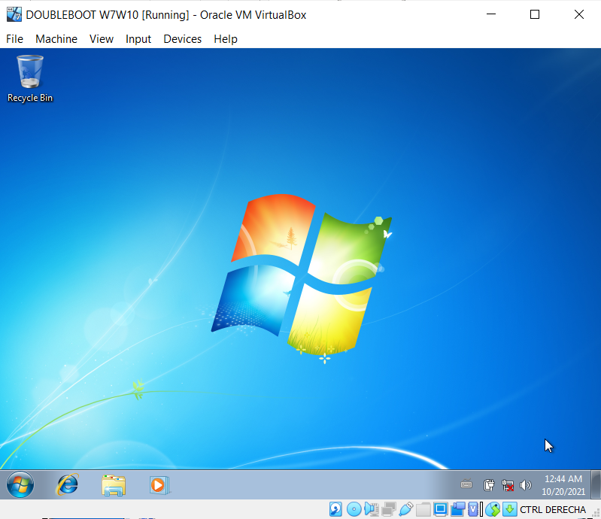

Now we have to change the cd to install the Windows 10.:

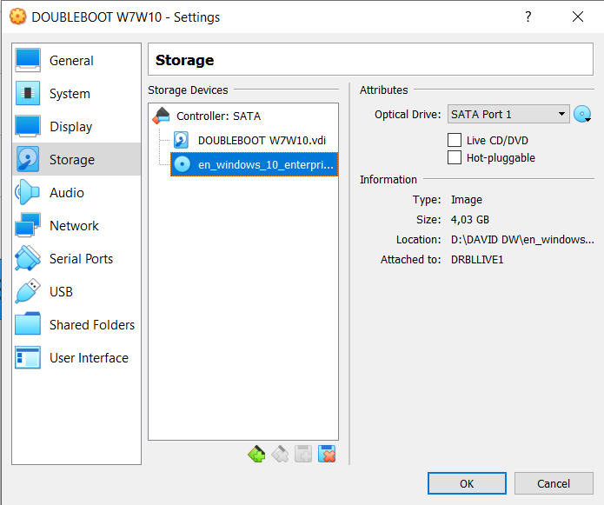

In this point we have to install Windows 10 as usually we do:

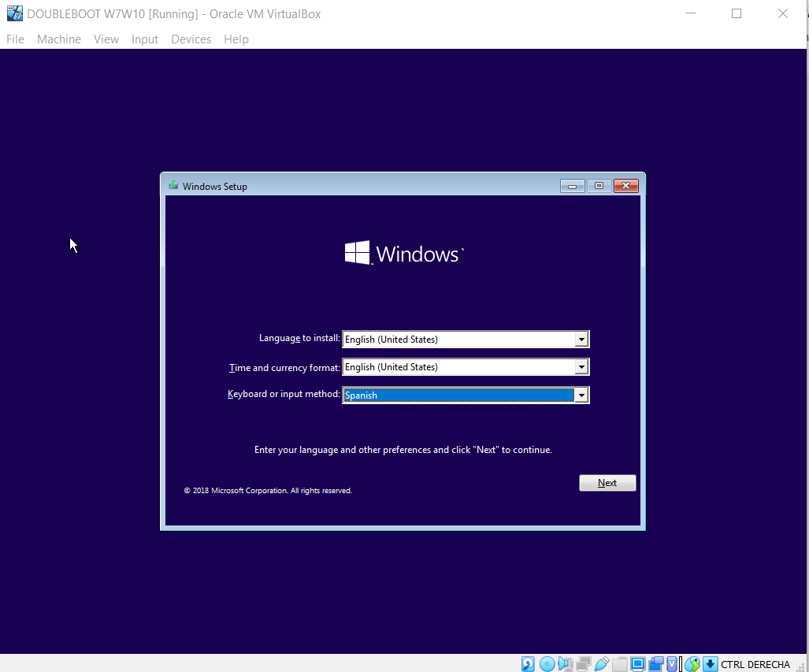

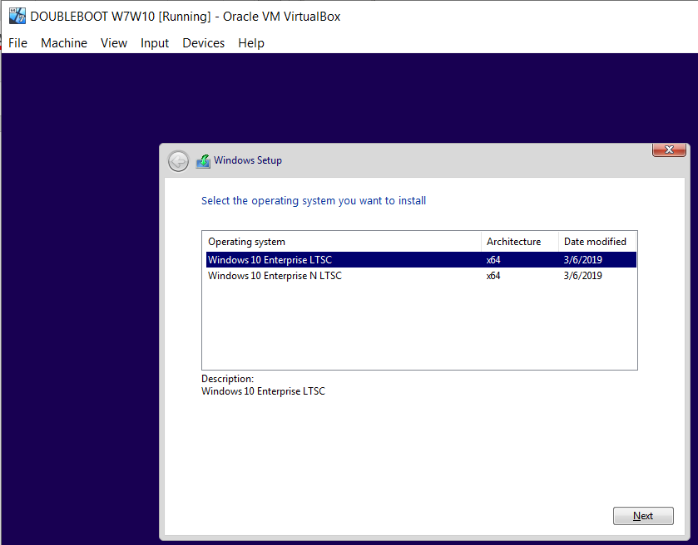

* Selecting the drive 0 Partition 3 to install it:

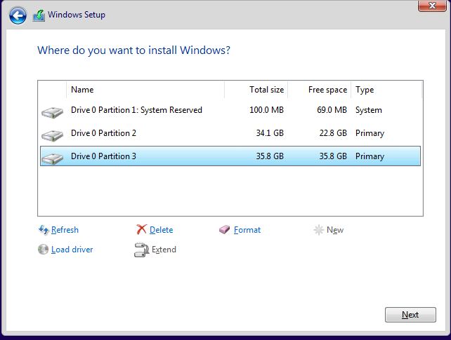

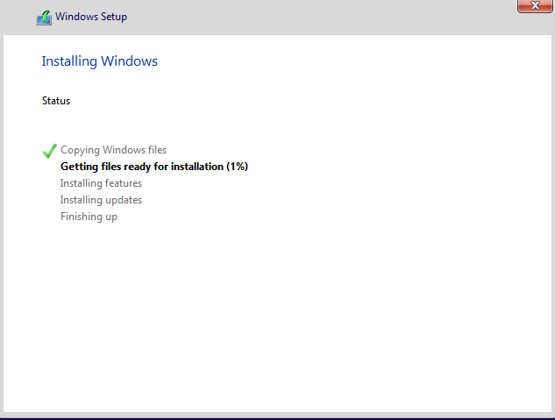

* Now we have both operating system installed:

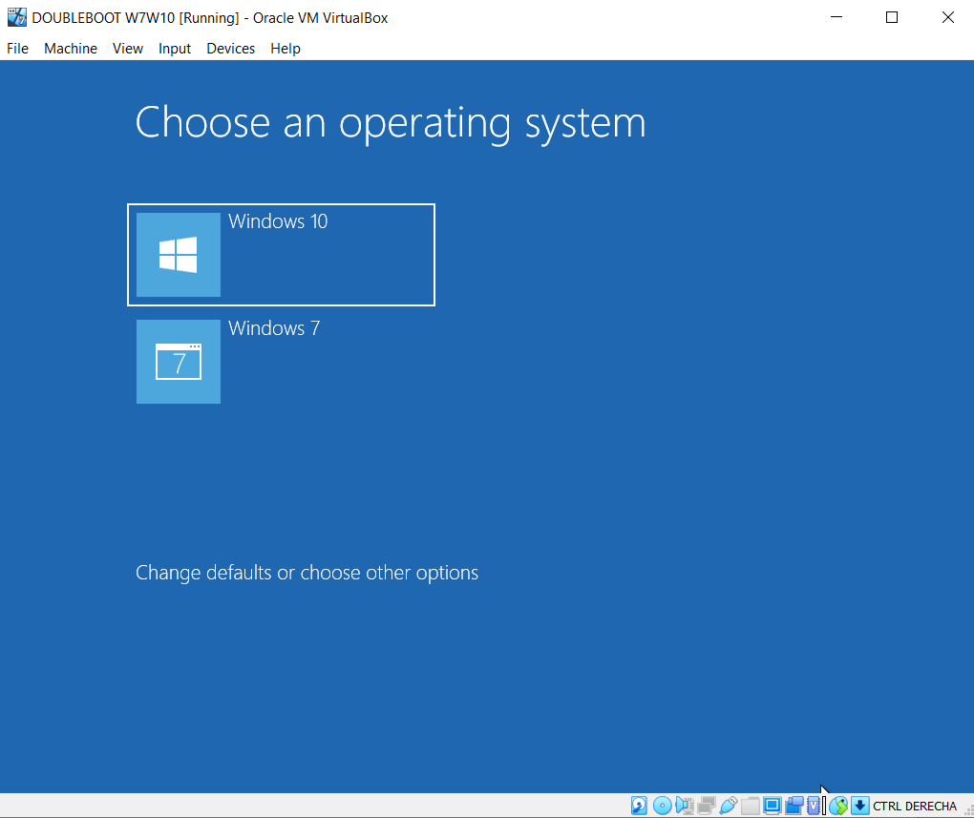

In order to have Windows 7 as the default operating system wich wil boot after 5 seconds unless Windows 10 is manually selected:

We can select the time in the option change the timer how is showed in the picture below:

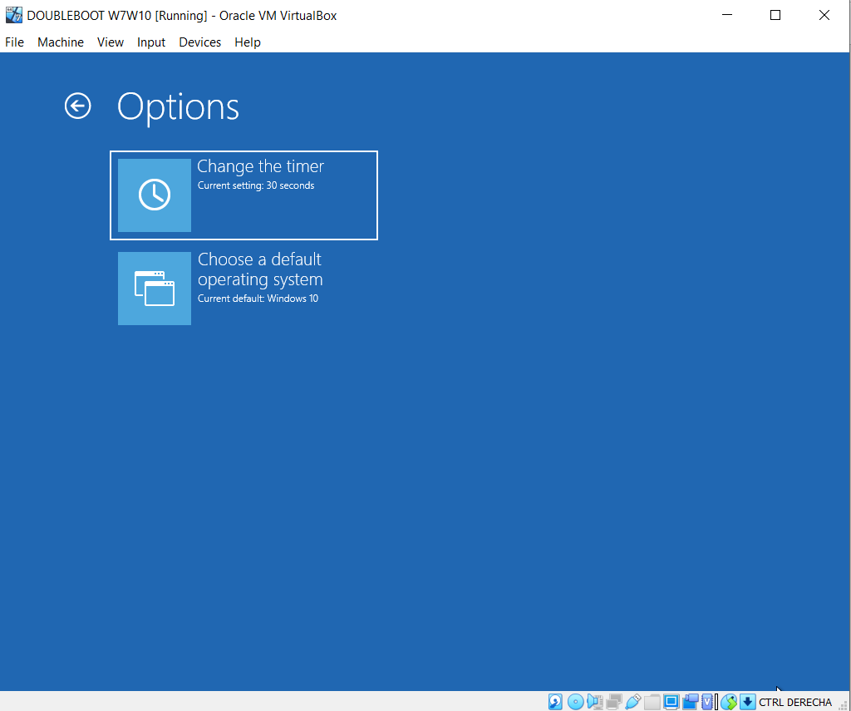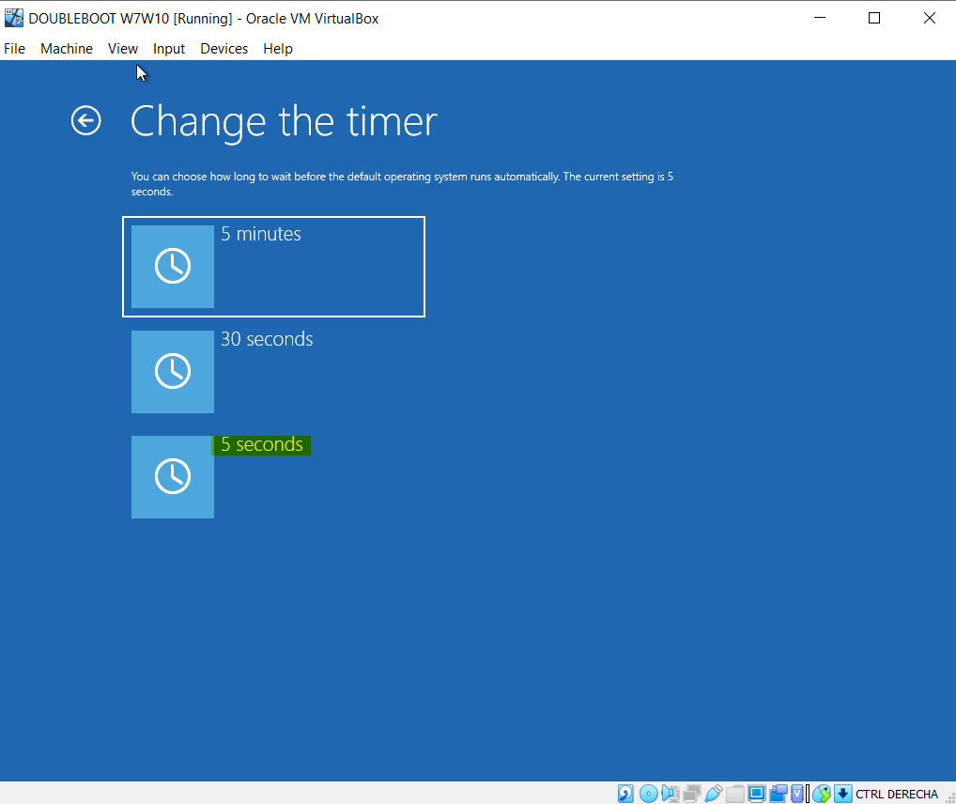

To change the default operating system we will select the option that is showed in the picture below:

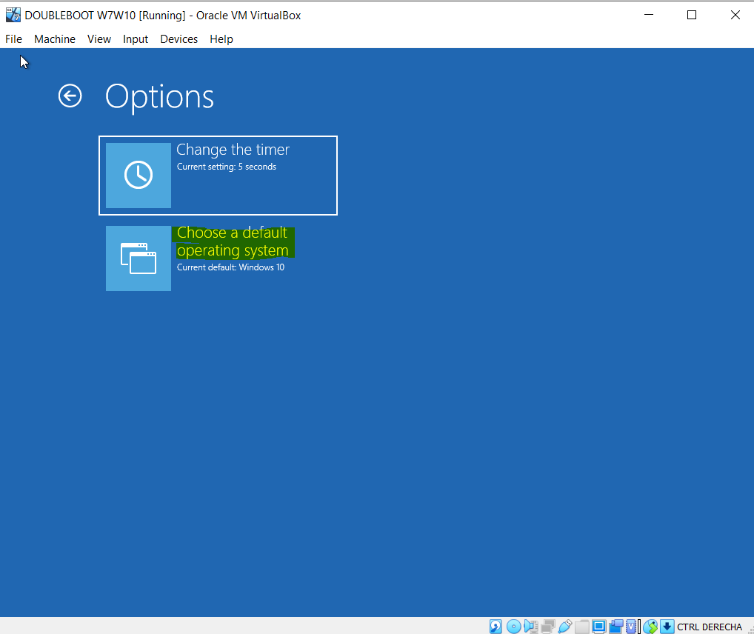

Finally the configuration is done:

